**MEDI-CAPS UNIVERSITY, INDORE**



**SESSION 2021-2022**

**PROGRAMMING I**

**(EN3ES21)**

**LAB FILE**

**Submitted To: Mrs. Niti Patil Submitted By: Sujal Soni**

**Scholar Number: 2100135**

**INDEX**

|  |  |  |
| --- | --- | --- |
| S No. | **Date** | **Objective** |
| 1. | 18/11/21 | Write a program to print hello user on output screen. |
| 2. | 18/11/21 | Write a program to perform arithmatic operation (+,-,*,/)of two numbers. |
| 3. | 18/11/21 | Write a program to take 3 numbers and display the sum of those numbers. |
| 4. | 18/11/21 | Write a program to use different data types to take input by scanf and display their sizes |
| 5. | 19/11/21 | W a Write a program to take three numbers and print their average upto two decimals. |
| 6. | 19/11/21 | Writ Write a program to calculate area of circle,square,rectangle etc. |
| 7. | 19/11/21 | Write a program to print the address of a variable in hexadecimal form. |
| 8. | 19/11/21 | Write a program to print ASCII value of a character. |
| 9. | 19/11/21 | Write a program to swap any two numbers. |
| 10. | 20/11/21 | Write a program to print table of a given number without using loop. |
| 11. | 25/11/21 | Write a program to print grade of student on the basis of percentage. |
| 12. | 25/11/21 | Write a program to check given year is leap year or not. |
| 13. | 25/11/21 | Write a program to print table of any number using while loop. |
| 14. | 26/11/21 | Writ Write a program to print if a number is even or odd. |
| 15. | 01/12/21 | Write a program to check if a number is prime number or not. |
| 16. | 01/12/21 | Write a program to calculate the factorial of a number. |
| 17. | 02/12/21 | Write a program to print right triangle star pattern. |
| 18. | 03/12/21 | Write a program to print whether a given number is palindrome or not. |
| 19. | 03/12/21 | Write a program to print a full triangle star pattern. |
| 20. | 05/12/21 | Write a program to print Alphabets in triangular pattern. |
| 21. | 05/12/21 | Write a program to print Alphabets in triangular star pattern 2. |
| 22. | 09/12/21 | Write a Program to print to check if a given char is Vowel or consonant. |
| 23. | 09/12/21 | Write a Program to print to check if a given char is Vowel or consonant. |

|  |  |  |
| --- | --- | --- |
| S No. | **Date** | **Objective** |
| 24. |  | Write a Program to print if a number os ARMSTRONG or not. |
| 25. |  | Write a program to print name of month according to number. (using switch). |
| 26. |  | Write a program to convert currency using switch case |
| 27. |  | Write a program for addition, subtraction, multiplication and division using switch case. |
| 28. |  | W a Write a program to print number in word in between 1-5. |
| 29. |  | Writ Write a Program to find maximum and minimum number from array. |
| 30. |  | Write a program to find how many numbers are PRIME & NOT PRIME in a list. |
| 31. |  | Write a program to check if a number is present or not in a list. |
| 32. |  | Write a program to arrange array elements in ascending or descending order. |
| 33. |  | Write a program to print a 2*2 matrix. |
| 34. |  | Write a program to find the sum of two matrix. |
|  |  |  |
|  |  |  |
| . |  | Writ |
|  |  |  |
|  |  |  |
| . |  |  |
|  |  |  |
|  |  |  |
|  |  |  |
|  |  |  |
|  |  |  |
|  |  |  |

**PRACTICAL-1**

**OBJECTIVE:-** Write a program to print hello user on output screen.

**PROGRAM:-**

#include<stdio.h>

Int main()

{

printf(“Hello User”);

return 0;

{

**OUTPUT:**

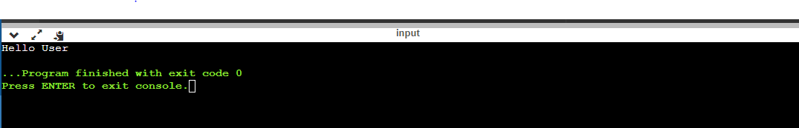

**PRACTICAL-2**

**OBJECTIVE:-** Write a program to perform arithmatic operation (+,-,*,/)of two numbers.

**PROGRAM:-**

int main()

{

int sum,difference,product,a=20,b=10;

float division;

sum=a+b;

printf("Sum of a=%d and b=%d is %d \n",a,b,sum);

difference=a-b;

printf("Difference of a=%d and b=%d is %d \n",a,b,difference);

product=a*b;

printf("Product of a=%d and b=%d is %d \n",a,b,product);

division=a/b;

printf("Division of a=%d and b=%d is %f ",a,b,division);

}

**OUTPUT:**

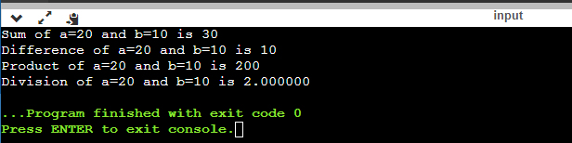

**PRACTICAL-3**

**OBJECTIVE:-** Write a program to take 3 numbers and display the sum of those numbers.

**PROGRAM:-**

#include <stdio.h>

void main()

{

int i,j,k,sum;

printf("Enter 3 numbers: ");

scanf("%d %d %d", &i, &j, &k);

sum = i+j+k;

printf("Sum of three numbers is %d", sum);

}

**OUTPUT:**

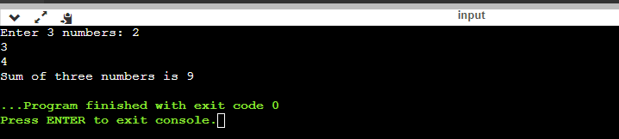

**PRACTICAL-4**

**OBJECTIVE:-** Write a program to use different data types to take input by scanf and display their sizes

**PROGRAM:-**

#include<stdio.h>

int main()

{

printf("int is of %d bytes \n",sizeof(int));

printf("float is of %d bytes \n",sizeof(float));

printf("char is of %d bytes \n",sizeof(char));

printf("double is of %d bytes \n",sizeof(double));

printf("long double is of %d bytes \n",sizeof(long double));

printf("shortint is of %d bytes \n",sizeof(short int));

}

**OUTPUT:**

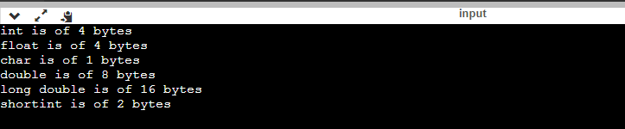

**PRACTICAL-5**

**OBJECTIVE:-** Write a program to take three numbers and print their average upto two decimals.

**PROGRAM:-**

#include<stdio.h>

#include<math.h>

int main()

{

float a,b,c,average;

printf("Enter 3 numbers to take average: ");

scanf("%f%f%f",&a,&b,&c);

average = (a+b+c)/3;

printf("Average of three numbers is %0.2f \n",average);

printf("Round-off Average of three numbers is %0.2f",round(average));

}

**OUTPUT:**

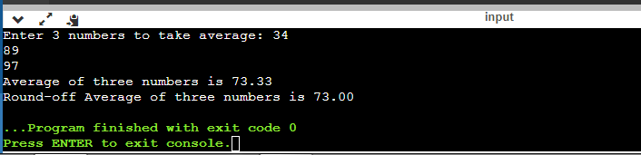

**PRACTICAL-6**

**OBJECTIVE:-** Write a program to calculate area of circle,square,rectangle etc.

**PROGRAM:-**

#include<stdio.h>

int main()

{

float r,areaofcircle;

printf("Enter radius: ");

scanf("%f",&r);

areaofcircle= 3.14*r*r;

printf("Area of Circle is: %f \n",areaofcircle);

float a,areaofsquare;

printf("Enter Side: ");

scanf("%f",&a);

areaofsquare= a*a;

printf("Area of Square is: %f \n",areaofsquare);

float l,b,areaofrect;

printf("Enter length and breadth: ");

scanf("%f%f",&l,&b);

areaofrect= l*b;

printf("Area of rectangle is: %f",areaofrect);

}

**OUTPUT:**

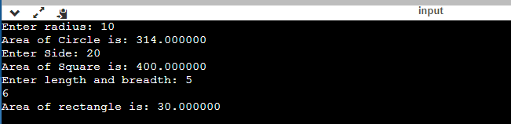

**PRACTICAL-7**

**OBJECTIVE:-** Write a program to print address of a variable in hexadecimal and Octal form.

**PROGRAM:-**

#include<stdio.h>

int main()

{

float h;

printf("Address of variable is %d \n",&h);

printf("Address of variable in hexadecimal form is %x",&h);

}

**OUTPUT:**

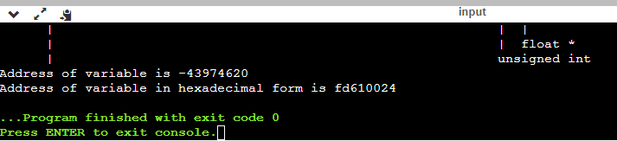

**PRACTICAL-8**

**OBJECTIVE:-** Write a program to print ASCII value of a character.

**PROGRAM:-**

#include<stdio.h>

int main()

{

char a;

printf("Enter a character whose ASCII value you want to print\n: ");

scanf("%c",&a);

printf("ASCII value of '%c' is %d",a,a);

return 0;

}

**OUTPUT:**

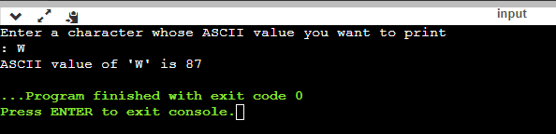

**PRACTICAL-9**

**OBJECTIVE:-** Write a program to swap any two numbers.

**PROGRAM:-**

#include<stdio.h>

int main()

{

int a,b,c;

printf("Enter the two numbers: \n");

scanf("%d%d",&a,&b);

printf("Before swapping the numbers a=%d b=%d \n",a,b);

c=a;

a=b;

b=c;

printf("After swapping the numbers a=%d b=%d",a,b);

}

**OUTPUT:**

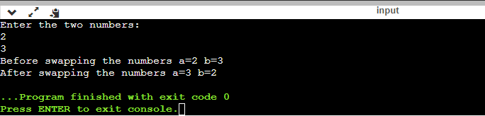

**PRACTICAL-10**

**OBJECTIVE:-** Write a program to print table of a given number without using loop.

**PROGRAM:-**

#include<stdio.h>

int main()

{

int a;

printf("Enter a number to print the table of: ");

scanf("%d",&a);

printf("%d * 1 = %d\n",a,a*1);

printf("%d * 2 = %d\n",a,a*2);

printf("%d * 3 = %d\n",a,a*3);

printf("%d * 4 = %d\n",a,a*4);

printf("%d * 5 = %d\n",a,a*5);

}

**OUTPUT:**

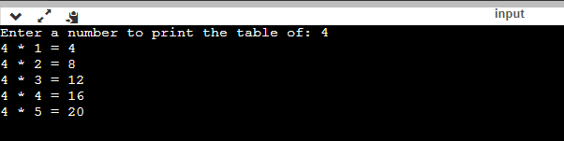

**PRACTICAL-11**

**OBJECTIVE:-** Write a program to print grade of student on the basis of percentage.

**PROGRAM:-**

#include <stdio.h>

int main()

{

int g;

printf("enter percentage: ");

scanf("%d",&g);

if (g>=95)

{

printf("A+ grade");

}

else if(g>=90 && g<95)

{

printf("A grade");

}

else if(g>=80 && g<90)

{

printf("B grade");

}

else if(g>=50 && g<80)

{

printf("C grade");

}

else

printf("D grade");

return 0;

}

**OUTPUT:**

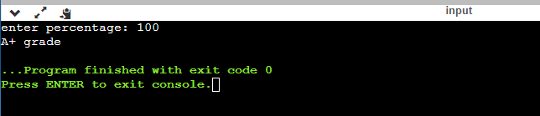

**PRACTICAL-12**

**OBJECTIVE:-** Write a program to check given year is leap year or not.

**PROGRAM:-**

#include <stdio.h>

int main()

{

int y;

printf("Enter year: ");

scanf("%d",&y);

if(((y%4==0)&&(y%100!=0))||(y%400==0)

{

printf("%d is a Leap Year", y);

}

else

printf("%d Not a Leap Year", y);

return 0;

}

**OUTPUT:**

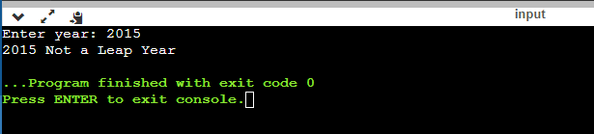

**PRACTICAL-13**

**OBJECTIVE:-** Write a program to print table of any number using while loop.

**PROGRAM:-**

#include <stdio.h>

int main()

{

int a, count=1;

printf("Enter the number you want to print the table of: ");

scanf("%d",&a);

while (count<=5)

{

printf("%d * %d = %d\n", a,count,a*count);

count++;

}

return 0;

}

**OUTPUT:**

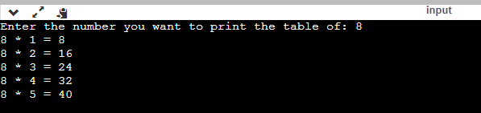

**PRACTICAL-14**

**OBJECTIVE:-** Write a program to print if a number is even or odd.

**PROGRAM:-**

#include <stdio.h>

int main()

{

float num;

printf("Enter a number: ");

scanf("%f",&num);

if (num%2.0==0)

{

printf("Even Number");

}

else

{

printf("Odd Number");

}

return 0;

}

OUTPUT:

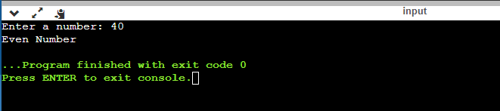

**PRACTICAL-15**

**OBJECTIVE:-** Write a program to check if a number is a Prime number or not.

**PROGRAM:-**

#include <stdio.h>

int main()

{

int n,i,counter=1;

printf("Enter a number to check if it is a prime number or not: ");

scanf("%d",&n);

for (i=2;i<n;i++)

{

if (n%i==0)

{

counter=0;

break;

}

printf("loop run for i=%d\n",i);

}

if (counter==0)

printf("It is not prime number");

else

printf("It is a prime number");

return 0;

}

OUTPUT:

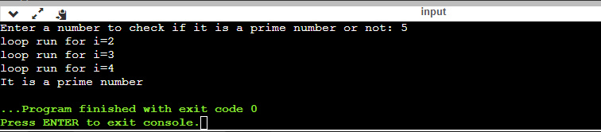

**PRACTICAL-16**

**OBJECTIVE:-** Write a program to calculate the factorial of any number.

**PROGRAM:-**

#include <stdio.h>

int main()

{

int a, count, factorial=1;

printf("Enter a number to find factorial of a number: ");

scanf("%d",&a);

for (count=1; count <= a; count++)

{

factorial=factorial*count;

}

printf("Factorial of %d is %d\n",a,factorial);

return 0;

}

OUTPUT:

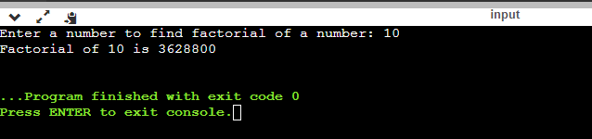

**PRACTICAL-17**

**OBJECTIVE:-** Write a program to print right triangle star pattern.

**PROGRAM:**-

#include <stdio.h>

int main()

{

int row, i, j;

printf("Enter the number of rows to print the right triangle star pattern: ")

scanf("%d",&row);

for(i=1; i<=row;i++) // to change row

{

for (j=1;j<=i;j++) //to print star

{

printf("*");

}

printf(“\n”);

}

return 0;

}

OUTPUT:

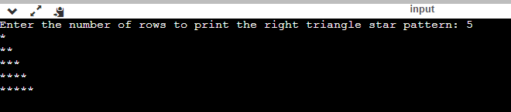

**PRACTICAL-18**

**OBJECTIVE:-** Write a program to print whether a given number is palindrome or not.

**PROGRAM:**-

#include <stdio.h>

int main()

{

int n,r,sum=0,b;

printf("enter the number: ");

scanf("%d",&n);

b=n;

while(n>0)

{

r=n%10;

sum=(sum*10)+r;

n=n/10;

}

if (b==sum)

printf("palindrome number");

else

printf("not palindrome");

return 0;

}

OUTPUT:

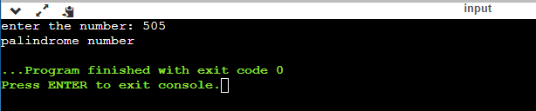

**PRACTICAL-19**

**OBJECTIVE:-** Write a program to print a full triangle star pattern.

**PROGRAM:**-

#include <stdio.h>

int main()

{

int row,i,j,k;

printf("enter number of rows: ");

scanf("%d",&row);

for(i=1;i<=row;i++) //row

{

for(j=1;j<=row-i;j++)//space

{

printf(" ");

}

for(k=1;k<=2*i-1;k++)

{

printf("*");

}

printf("\n");

}

}

OUTPUT:

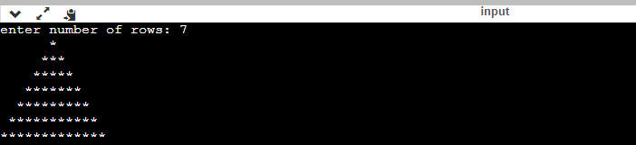

**PRACTICAL-20**

**OBJECTIVE:-** Write a program to print Alphabets in right triangular pattern.

**PROGRAM:**-

#include <stdio.h>

int main()

{

int i,j,n;

printf("Enter number of rows: ");

scanf("%d",&n);

for(i=1;i<=n;i++)

{

for(j=1;j<=i;j++)

{

printf("%c",'A'-1+i);

}

printf("\n");

}

return 0;

}

OUTPUT:

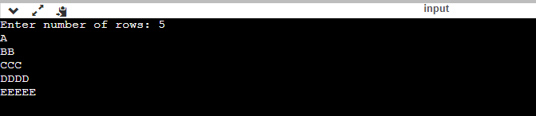

**PRACTICAL-21**

**OBJECTIVE:-** Write a program to print Alphabets in right triangular pattern2.

**PROGRAM:**-

#include <stdio.h>

int main()

{

int i,j,n;

char c='A';

printf("Enter number of rows: ");

scanf("%d",&n);

for(i=0;i<n;i++)

{

for(j=0;j<=i;j++)

{

printf("%c ",c);

c++;

}

printf("\n");

}

return 0;

}

OUTPUT:

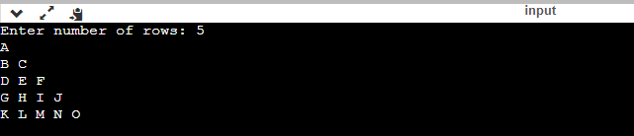

**PRACTICAL-22**

**OBJECTIVE:-** Write a Program to print to check if a given char is Vowel or consonant.

**PROGRAM:**-

#include <stdio.h>

int main()

{

char ch;

int lower,upper;

printf("Enter an Alphabet: ");

scanf("%c", &ch);

lower= (ch=='a'||ch=='e'||ch=='i'||ch=='o'||ch=='u');

upper= (ch=='A'||ch=='E'||ch=='I'||ch=='O'||ch=='U');

if(lower||upper)

{

printf("%c is a VOVEL", ch);

}

else{

printf("%c is a CONSONANT", ch);

}

return 0;

}

OUTPUT:

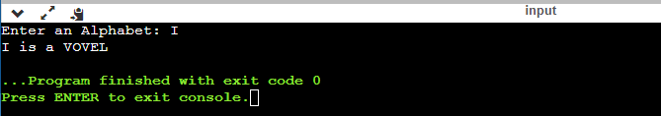

**PRACTICAL-23**

**OBJECTIVE:-** Write a Program to print if a number is ARMSTRONG or not (320= 3 cube + 2 cube + 0 cube)

**PROGRAM:**-

#include <stdio.h>

int main()

{

int num,x,xremainder, result=0;

printf("Enter a three digit number: ");

scanf("%d",&num);

x=num;

while (x!=0)

{

xremainder = x % 10; //to take out one digit from the number

result += xremainder*xremainder*xremainder; // cube of digit

x= x/10; // removing last digit

}

if (result == num)

{

printf("%d is ARMSTRONG Number", num);

}

else{

printf("%d is not ARMSTRONG number", num);

}

return 0;

}

OUTPUT:

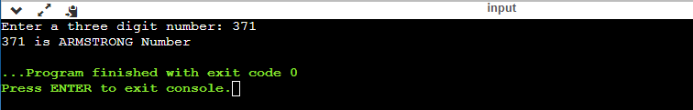

**PRACTICAL-24**

**OBJECTIVE:-** Write a program to print name of month according to number. (using switch).

**PROGRAM:**-

#include <stdio.h>

int main()

{

int a,i;

printf("Enter a number of Month: ");

scanf("%d", &a);

switch(a)

{

case 1 :

printf("January");

break;

case 2 :

printf("February");

break;

case 3:

printf("March");

break;

case 4 :

printf("April");

break;

case 5 :

printf("May");

break;

case 6 :

printf("June");

break;

case 7 :

printf("July");

break;

case 8 :

printf("August");

break;

case 9 :

printf("September");

break;

case 10 :

printf("October");

break;

case 11 :

printf("November");

break;

case 12 :

printf("December");

break;

default:

printf("Wrong Choice");

}

return 0;

}

OUTPUT:

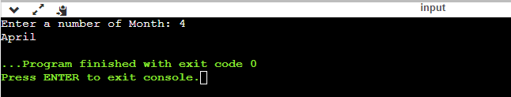

**PRACTICAL-25**

**OBJECTIVE:-** Write a program to convert currency using switch case

**PROGRAM:**-

#include <stdio.h>

int main()

{

float x, a;

int i;

printf("Enter currency in Rupees: ");

scanf("%f", &x);

printf("Enter 1 for DOLLARS and 2 for DIRHAM: ");

scanf("%d",&i);

switch(i)

{

case 1:

a = x*1/70;

printf("%f converted to DOLLARS= %f $", x,a);

break;

case 2:

a = x*0.049;

printf("%f converted to DIRHAM= %f Dirham", x,a);

break;

default:

printf("Wrong Choice");

}

return 0;

}

OUTPUT:

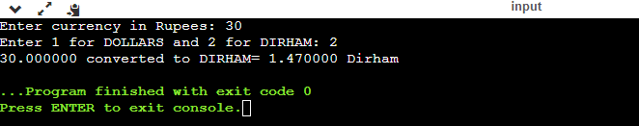

**PRACTICAL-26**

**OBJECTIVE:-** Write a program for addition, subtraction, multiplication and division using switch case.

**PROGRAM:**-

#include <stdio.h>

int main()

{

int a,b,c,i;

printf("Enter 2 numbers: ");

scanf("%d%d",&a,&b);

printf("Choose 1 to Add, 2 to Subtract, 3 to Multiply and 4 to Divide: ");

scanf("%d",&i);

switch(i)

{

case 1: c=a+b;

printf("c=%d",c);

break;

case 2: c=a-b;

printf("c=%d",c);

break;

case 3: c=a*b;

printf("c=%d",c);

break;

case 4: c=a/b;

printf("c=%d",c);

break;

default:

printf("Wrong Choice");

}

return 0;

}

OUTPUT: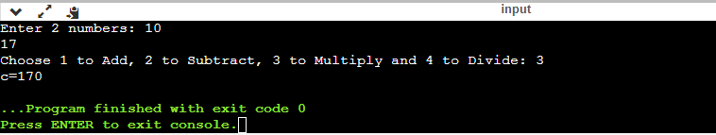

**PRACTICAL-27**

**OBJECTIVE:-** Write a program to print number in word in between 1-5.

**PROGRAM:**-

#include <stdio.h>

int main()

{

int a;

printf("Enter any number from 1 to 5: ");

scanf("%d",&a);

switch(a)

{

case 1:

printf("1=one");

break;

case 2:

printf("2=two");

break;

case 3:

printf("3=three");

break;

case 4:

printf("4=four");

break;

case 5:

printf("5=five");

break;

default:

printf("Wrong choice");

}

return 0;

}

OUTPUT:

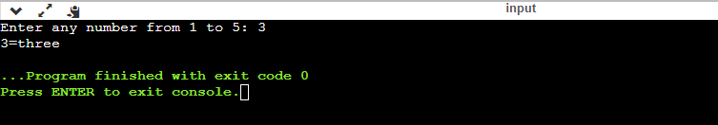

**PRACTICAL-28**

**OBJECTIVE:-** Write a program to find Maximum and Minimum Number from array.

**PROGRAM:**-

#include <stdio.h>

int main()

{

int arr[100], i, max, min, len;

printf("Enter size of array: ");

scanf("%d",&len);

printf("Enter elements of array: ");

for (i=0; i<len; i++)

{

scanf("%d", &arr[i]);

}

min=max=arr[0];

for (i=1; i<len; i++)

{

if(min>arr[i])

min=arr[i];

if(max<arr[i])

max=arr[i];

}

printf("Minimum number from array= %d\n", min);

printf("Maximum number from array= %d", max);

return 0;

}

OUTPUT:

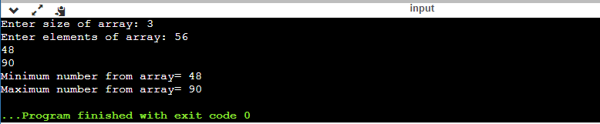

**PRACTICAL-29**

**OBJECTIVE:-** Write a program to find how many numbers are PRIME & NOT PRIME in a list.

**PROGRAM:**-

#include <stdio.h>

int main()

{

int i, a[20], len, x, prime=0, count=0 ;

printf("Enter the size of array: ");

scanf("%d",&len);

printf("Enter the elements: ");

for(i=0; i<len; i++)

{

scanf("%d",&a[i]);

}

for (i=1; i<len;i++)

{

for (x=2;x<a[i];x++)

{

if(a[i]%x==0)

{

count+=1;

break;

}

if(a[1]%x!=0)

{

prime+=1;

}

}

}

printf("Count of PRIME numbers: %d\n", prime);

printf("Count of non PRIME numbers: %d", count);

return 0;

}

OUTPUT:

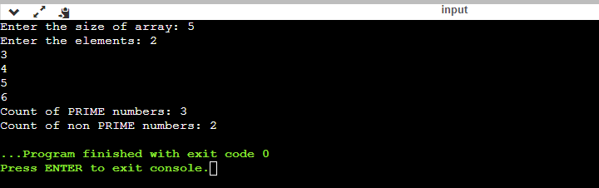

**PRACTICAL-30**

**OBJECTIVE:-** Write a program to check if a number is present in the list or not.

**PROGRAM:**-

#include <stdio.h>

int main()

{

int ar[5]={10,20,30,40,50};

int x, i;

printf("Enter the number to search: ");

scanf("%d",&x);

for (i=0;i<5;i++)

{

if (ar[i]==x)

{

printf("Number found at index %d",i);

break;

}

}

return 0;

}

OUTPUT:

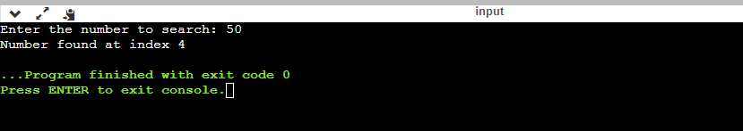

**PRACTICAL-31**

**OBJECTIVE:-** Write a program to arrange or sort array elements in ascending or descending order.

**PROGRAM:**-

#include <stdio.h>

int main()

{

int a[10],x,y,z,i,j,temp,temp1;

printf("Enter the size of array: ");

scanf("%d",&x);

printf("Enter the Elements: ");

for(i=0; i<x; i++)

{

scanf("%d",&a[i]);

}

//for ascending order

for(i=0;i<x;i++)

{

for(j=i+1; j<x ; j++)

{

if(a[i]>a[j])

{

temp=a[i];

a[i]=a[j];

a[j]=temp;

}

}

}

printf("Ascending order of array: ");

for (i=0; i<x; i++)

{

printf("%d\t", a[i]);

}

//for descending order

for(y=0; y<x ; y++)

{

for(z=y+1; z<x; z++)

{

if(a[y]<a[z])

{

temp1=a[y];

a[y]=a[z];

a[z]=temp1;

}

}

}

printf("\nDescending Order of array: ");

for (y=0; y<x; y++)

{

printf("%d\t",a[y]);

}

return 0;

}

OUTPUT:

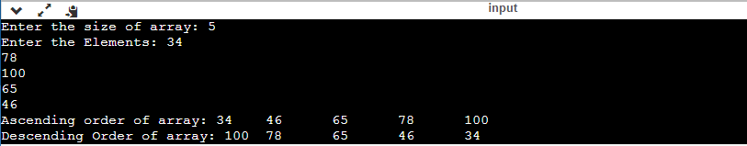

**PRACTICAL-32**

**OBJECTIVE:-** Write a program to print a 2*2 matrix

**PROGRAM:**-

#include <stdio.h>

int main()

{

int a[2][2]={

{1,2},

{3,4}

};

int i,j;

for (i=0; i<2; i++)

{

for (j=0; j<2; j++)

{

printf("%d\t", a[i][j]);

}

printf("\n");

}

return 0;

}

OUTPUT:

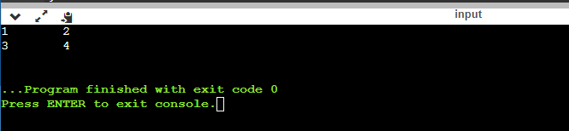

**PRACTICAL-33**

**OBJECTIVE:-** Write a program to find the sum of two matrix.

**PROGRAM:**-

**#include <stdio.h>**

**int main()**

**{**

**int i, j, a[3][2]={{2,1},{5,6},{8,9}}, b[3][2]={{5,4},{3,7},{9,1}};**

**for (i=0; i<3; i++)**

**{**

**for (j=0; j<2; j++)**

**{**

**printf("%d\t",a[i][j]+b[i][j]);**

**}**

**printf("\n");**

**}**

**return 0;**

**}**

SAME WOULD BE THE CODE FOR PRINTING THE SUM OF A 3*3 MATRIX.

OUTPUT:

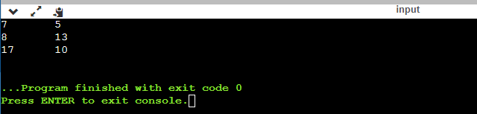

**PRACTICAL-34**

**OBJECTIVE:-** Write a program to print 3*3 matrix.

**PROGRAM:**-

#include <stdio.h>

int main()

{

int a[10][10], rows, columns, i, j;

printf("Enter the number of rows and columns: ");

scanf("%d %d", &rows, &columns);

for(i=0; i<rows; i++)

{

for(j=0; j<columns; j++)

{

printf("Enter the element at {%d %d} position: ", i+1, j+1);

scanf("%d", &a[i][j]);

}

}

printf("The matrix is as follows: \n")

for(i=0; i<rows; i++)

{

for(j=0; j<columns; j++)

{

printf(" %d ", a[i][j]);

}

printf("\n");

}

return 0;

}

**OUTPUT**

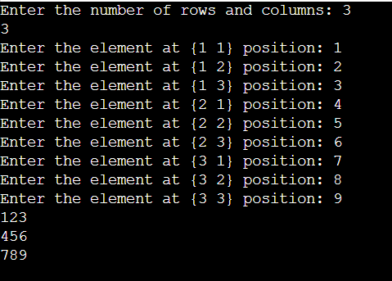

**PRACTICAL-35**

**OBJECTIVE:-** Write a program to print the sum of ROWS and COLUMNS of a 3*3 matrix.

**PROGRAM:**-

#include<stdio.h>

int main(){

int i,j, sum=0;

int a[3][3]={{1,2,3},

{4,5,6},

{7,8,9}};

printf("Row Total: ");

for(i=0; i<3; i++)

{

for(j=0; j<3; j++)

{

sum+= a[i][j];

}

printf("%d\t",sum);

sum=0;

}

printf("\n");

printf("Column Total: ");

for(j=0; j<3; j++)

{

for(i=0; i<3; i++)

{

sum+= a[i][j];

}

printf("%d\t",sum);

sum=0;

}

}

**OUTPUT**



**PRACTICAL-36**

**OBJECTIVE:-** Write a program to multiply 2 matrix.

**PROGRAM:**-

Pending